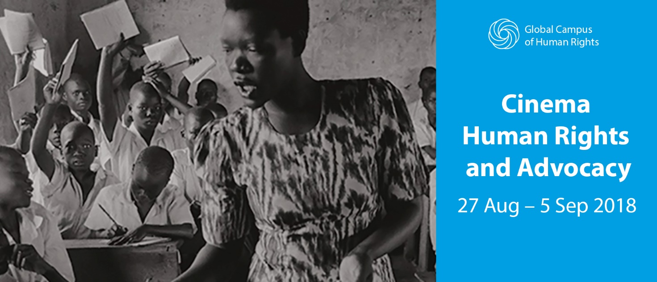
13th Cinema Human Rights and Advocacy – Summer School
The 13th edition of the Summer School in Cinema Human Rights and Advocacy is a training initiative jointly developed by EIUC and CHRA. The 10-day intense training is aimed at young professionals wishing to broaden their understanding on the connections between human rights, films, digital media and video advocacy, to share ideas and foster participatory and critical thinking on urgent human rights issues, debate with experts and filmmakers from all over the world during the 75th Venice international Film Festival and learn how to use films as a tool for social and cultural change.
The Programme
The Summer School offers an exciting programme of lectures, film screenings, discussions and working groups that combine human rights expertise, media studies and video advocacy strategies. The eight sessions develop issues relating to the Universal Declaration of Human Rights illustrated in Films, a History of Human Rights Cinema, Freedom of Expression and Censorship, the Role of the Media in Advancing Human Rights Causes, the Use of Video in Human Rights Documentation and Advocacy, Production and Distribution of Human Rights Films and Social Documentaries, The Role of the New Media during Conflict, Documentary Film Project Development. Each module is illustrated by film or documentary screenings.
The workshop introduces storytelling and storyboarding key concepts, techniques and exercises that provide participants with the basic skills to develop a short film project to be pitched on the school’s final session. For the purpose of this workshop, participants will work and be tutored in small teams.
As part of the programme participants are required to watch and analyse a selection of human rights related screenings at the 75th Venice International Film Festival. Whenever possible, filmmakers, jury members and critics from the cinema world are invited to participate to discussions with the summer school participants. Participants will be given a Cinema Accreditation for the whole duration of the Venice International Film Festival giving access to a selection of festival screenings.
The school programme may be subject to changes during the film festival period in order to accommodate festival screenings and meetings with festival’s personalities with teaching sessions.
The programme doesn’t include technical aspects of filmmaking and film production.
The Faculty
The faculty is composed by internationally acclaimed experts in film, television, photography and human rights such as: Nick Danziger, photographer and filmmaker; Claudia Modenesi, human rights expert and media trainer with a background in Film studies and an MA in human rights studies; Charlotte Lindsey – Curtet, director of Communication And Information Management at International Committee Of The Red Cross (ICRC); Koen de Feyter, professor of International Law at the University of Antwerp and part-time Professor at PILC and the University of Maastricht; Christopher Hird, Dartmouth Films Founder and Managing Director; Kelly Matheson human rights attorney and award-winning filmmaker who leads WITNESS’ Video as Evidence program; Manfred Nowak, professor of International Law and Human Rights and EIUC - Global Campus Secretary General; Emma Sandon, Senior Lecturer in Film and Television, Birkbeck University of London; and William Schabas, professor of International Law, Middlesex University London.
Early Bird: 9 May 2018
Registration deadline: 20 June 2018
Course dates: 27 August – 5 September
Target: Graduates, professionals of the human rights, media, NGO and advocacy sector and anyone who uses or is interested in using audio-visual media as a tool for promoting social change are encouraged to apply to the Summer School.
The School selects a maximum of 30 participants.
For more information, contact us at chra@eiuc.org or visit https://eiuc.org/chra

