***European Lawyers in Lesvos* - Application form for volunteer lawyers**

*Basic information:*

Surname _________________________ Name _______________________________

Gender _________________________

Address ____________________________________________________________________

Mobile phone number ___________________________________________

Email-address __________________________________________________

Nationality __________________________________________________

Date of birth __________________________

*Professional information:*

Member of ________________________ Bar since ________________________

CCBE Member bar/law society _______________________________________________________

Experience in Asylum Law practice (in years/number of cases) _________________

Other relevant experience in dealing with migrant affairs ______________________

*Language Competences:*

|  |  |  |  |  |
| --- | --- | --- | --- | --- |
| **Languages** | **Level** | | | |
|  | **Native** | **Fluent** | **Intermediate** | **Beginner** |
| **English** |  |  |  |  |
| **Arabic** |  |  |  |  |
| **Greek** |  |  |  |  |
| **Farsi** |  |  |  |  |
| **French** |  |  |  |  |
| **Other**  **___________** |  |  |  |  |

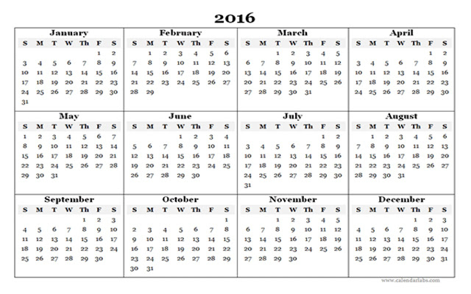*Availability in calendar weeks in 2016 (please circle/highlight):*

Preferred period of volunteer activity (min. 2 consecutive weeks) ____________

*Please attach the following documents:*

* A copy of certificate of admission to/membership of the bar
* Curriculum Vitae
* Please describe in one page why you are suitable for this project (in English)